PTSD Data Analysis

## Geder graph

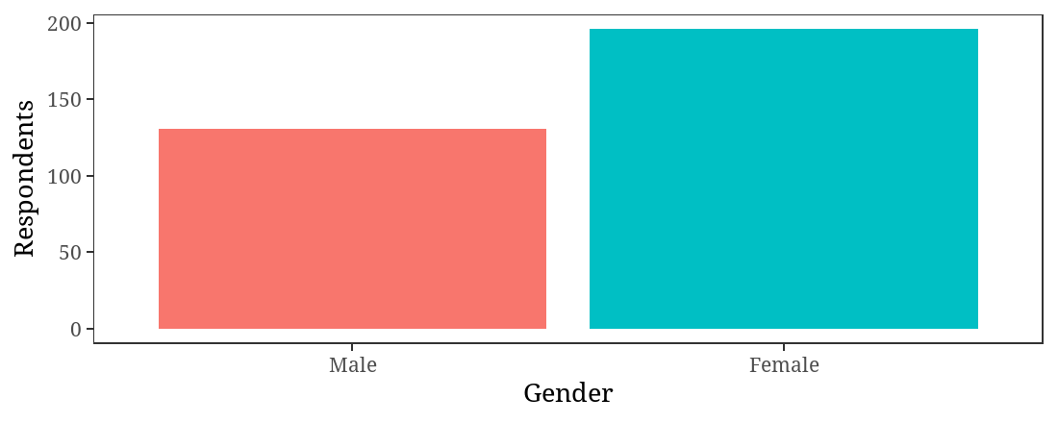

## Age graph

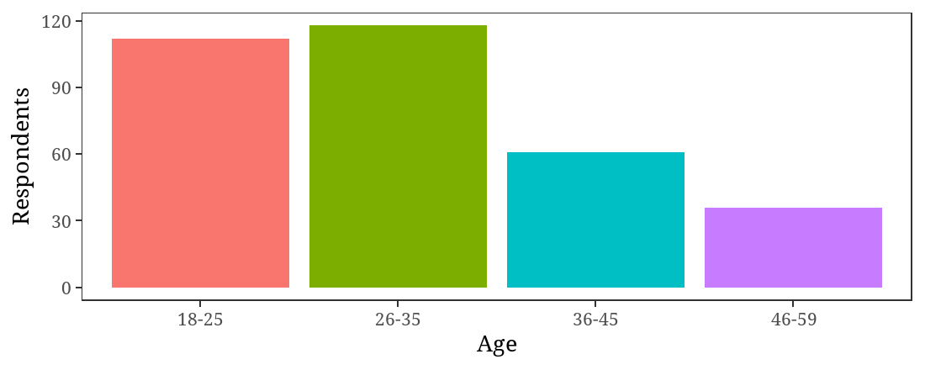

## Marital Status graph

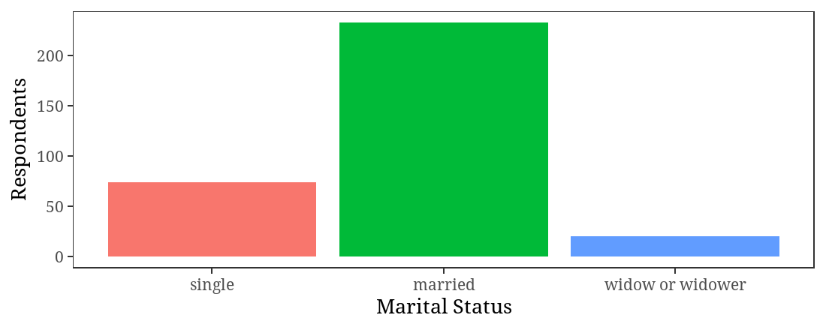

## Education level graph

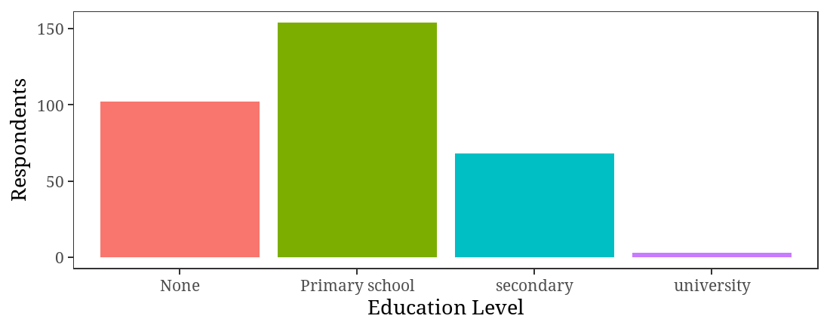

## Age graph



## PTSD Graph

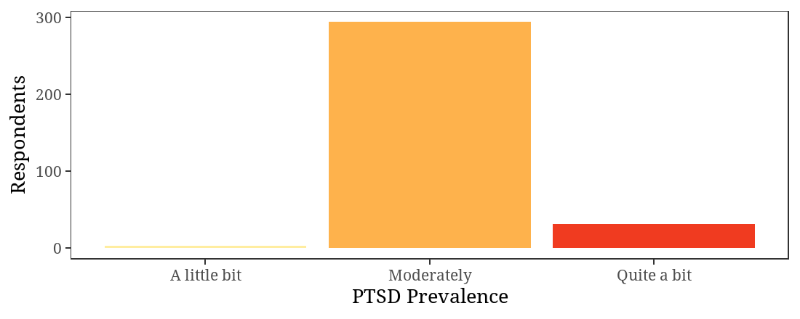

### REEXPERIENCES

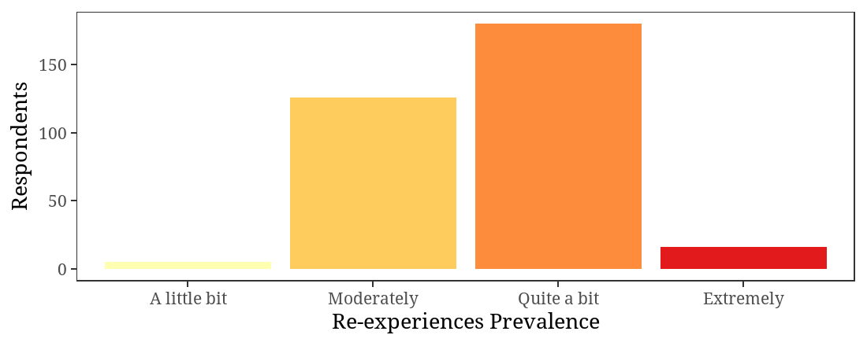

### Avoidance

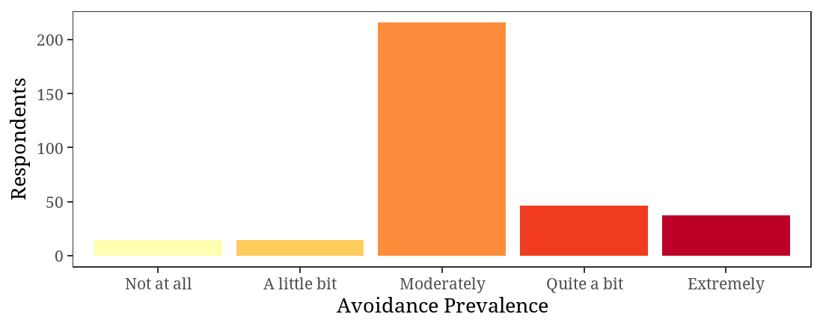

### Negative alterations

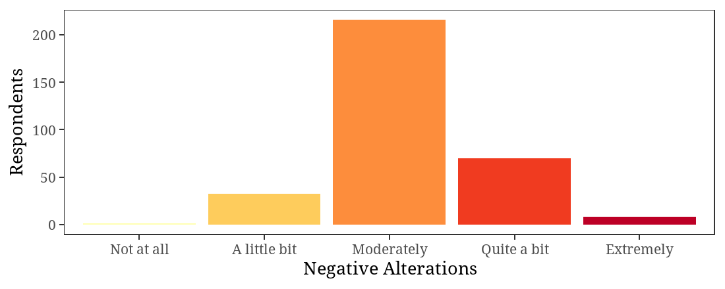

### Hyper-arousal

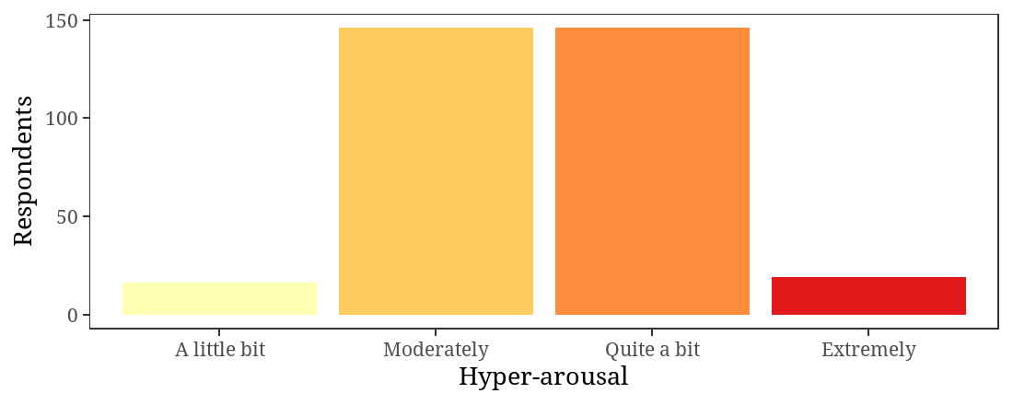

## Depression Graph

|  |
| --- |
|  |

Depression scores and PTSD scores have a direct positive correlation of 0.3. When PTSD increases, Depression increases as well.

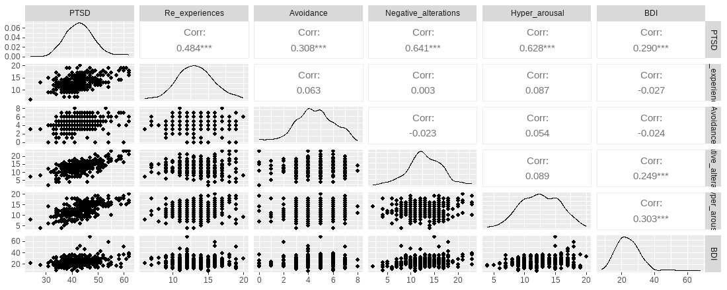

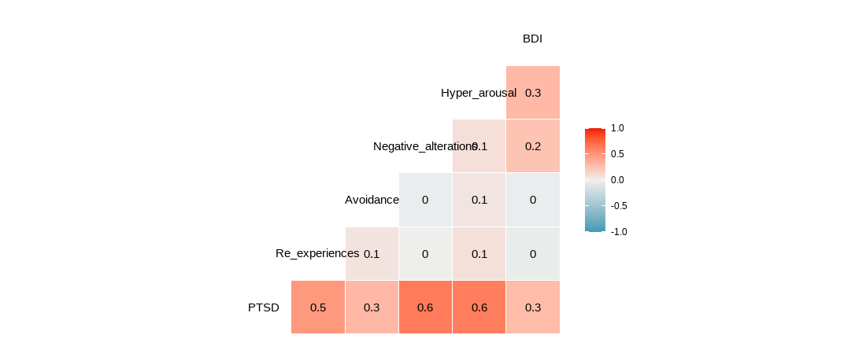

| term | PTSD | Re_experiences | Avoidance | Negative_alterations | Hyper_arousal | BDI |
| --- | --- | --- | --- | --- | --- | --- |
| PTSD | NA | 0.484087362 | 0.30800695 | 0.641459461 | 0.62843728 | 0.28995227 |
| Re_experiences | 0.4840874 | NA | 0.06270252 | 0.002578818 | 0.08682272 | -0.02739269 |
| Avoidance | 0.3080070 | 0.062702520 | NA | -0.023471076 | 0.05429307 | -0.02363086 |
| Negative_alterations | 0.6414595 | 0.002578818 | -0.02347108 | NA | 0.08897492 | 0.24852373 |
| Hyper_arousal | 0.6284373 | 0.086822719 | 0.05429307 | 0.088974916 | NA | 0.30276080 |
| BDI | 0.2899523 | -0.027392692 | -0.02363086 | 0.248523729 | 0.30276080 | NA |